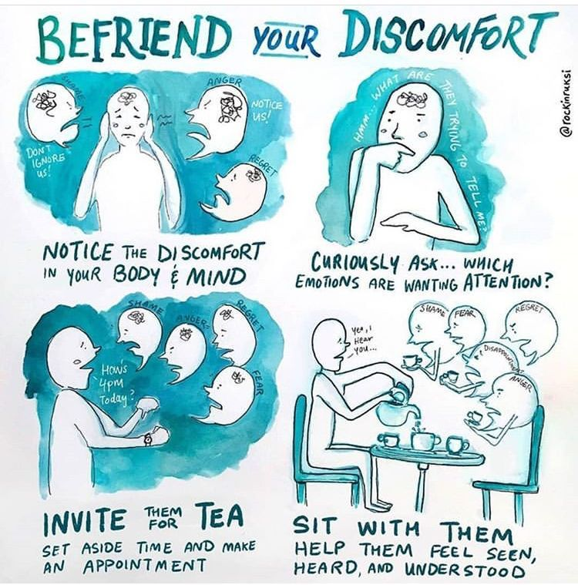Befriend your discomfort" is a concept that encourages us to acknowledge, accept, and work with our uncomfortable feelings or situations rather than avoiding or resisting them. This approach is rooted in mindfulness and psychological resilience practices. The idea is that by facing discomfort directly and learning to sit with it, we can develop greater emotional strength, self-awareness, and adaptability.  
  
How It Helps Us?  
  
1. Builds Resilience: When we face discomfort rather than avoiding it, we train ourselves to handle difficult situations better. This builds mental and emotional resilience, allowing us to navigate future challenges with more confidence.  
  
2. Promotes Personal Growth: Discomfort often arises when we are in unfamiliar situations or pushing our boundaries. By embracing it, we can grow and expand our capabilities, whether it's learning a new skill, adapting to change, or developing healthier habits.  
  
3. Reduces Anxiety: Avoiding discomfort can lead to increased anxiety because the things we avoid often loom larger in our minds. By confronting discomfort, we can reduce its power over us, leading to a decrease in anxiety and stress.  
  
4. Enhances Self-Awareness: Discomfort can be a signal that something in our life needs attention. By paying attention to these feelings, we can gain deeper insights into our needs, desires, and potential areas for growth.  
  
5. Improves Decision-Making: When we're not afraid of discomfort, we're more likely to make decisions that align with our long-term goals rather than opting for short-term comfort. This can lead to better outcomes in both personal and professional life.  
  
6. Encourages Mindfulness: Befriending discomfort is a key aspect of mindfulness, where we observe our thoughts and feelings without judgment. This practice can lead to a more peaceful and centered state of mind, even in challenging situations.  
  
In essence, by befriending discomfort, we learn to transform it from something to be feared into a valuable teacher that helps us become stronger, wiser, and more authentic in our lives.